1. The IP address is 192.168.1.102

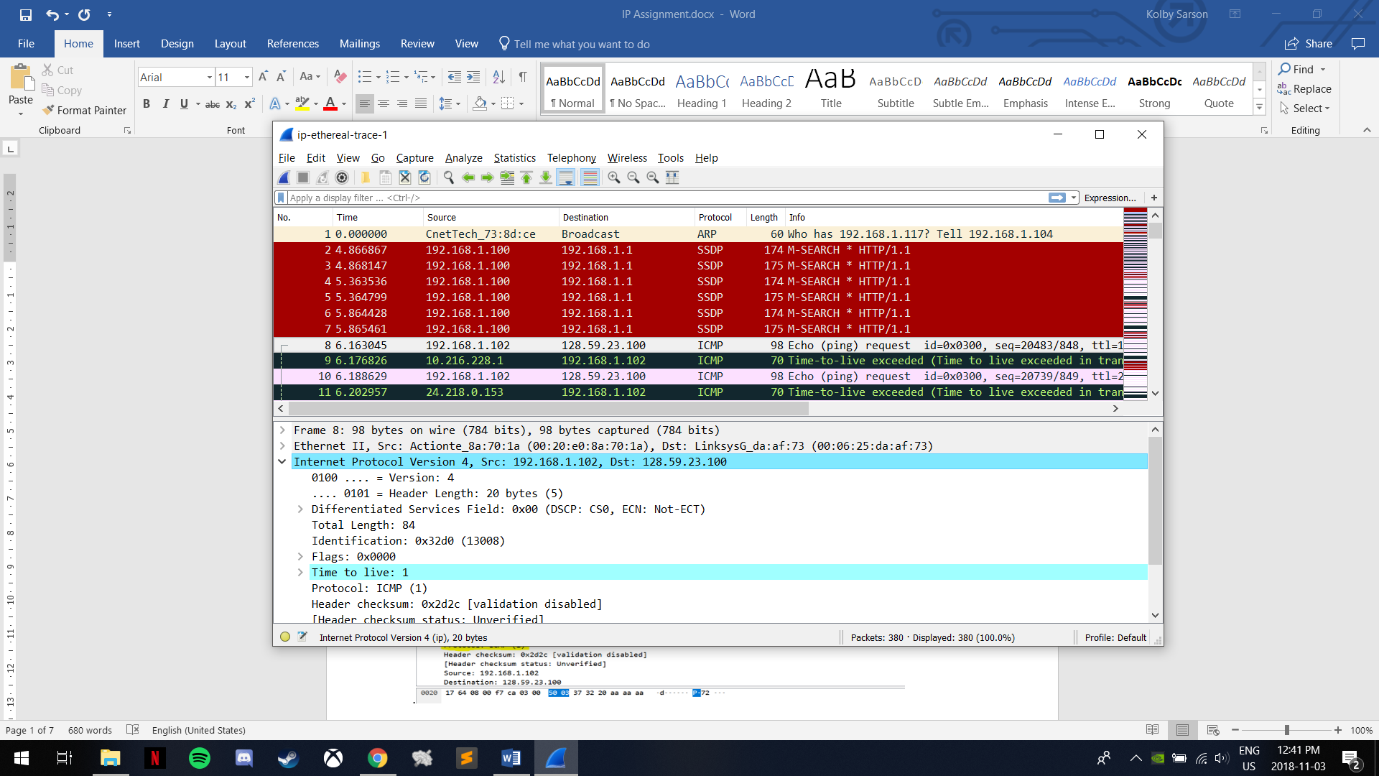

2**.** The value is ICMP (1)



1. There are 20 bytes in the IP header and 84 bytes in the packet. Therefore, the payload is 64 bytes.



1. A Fragment offset of 0 indicates that the datagram has not been fragmented.

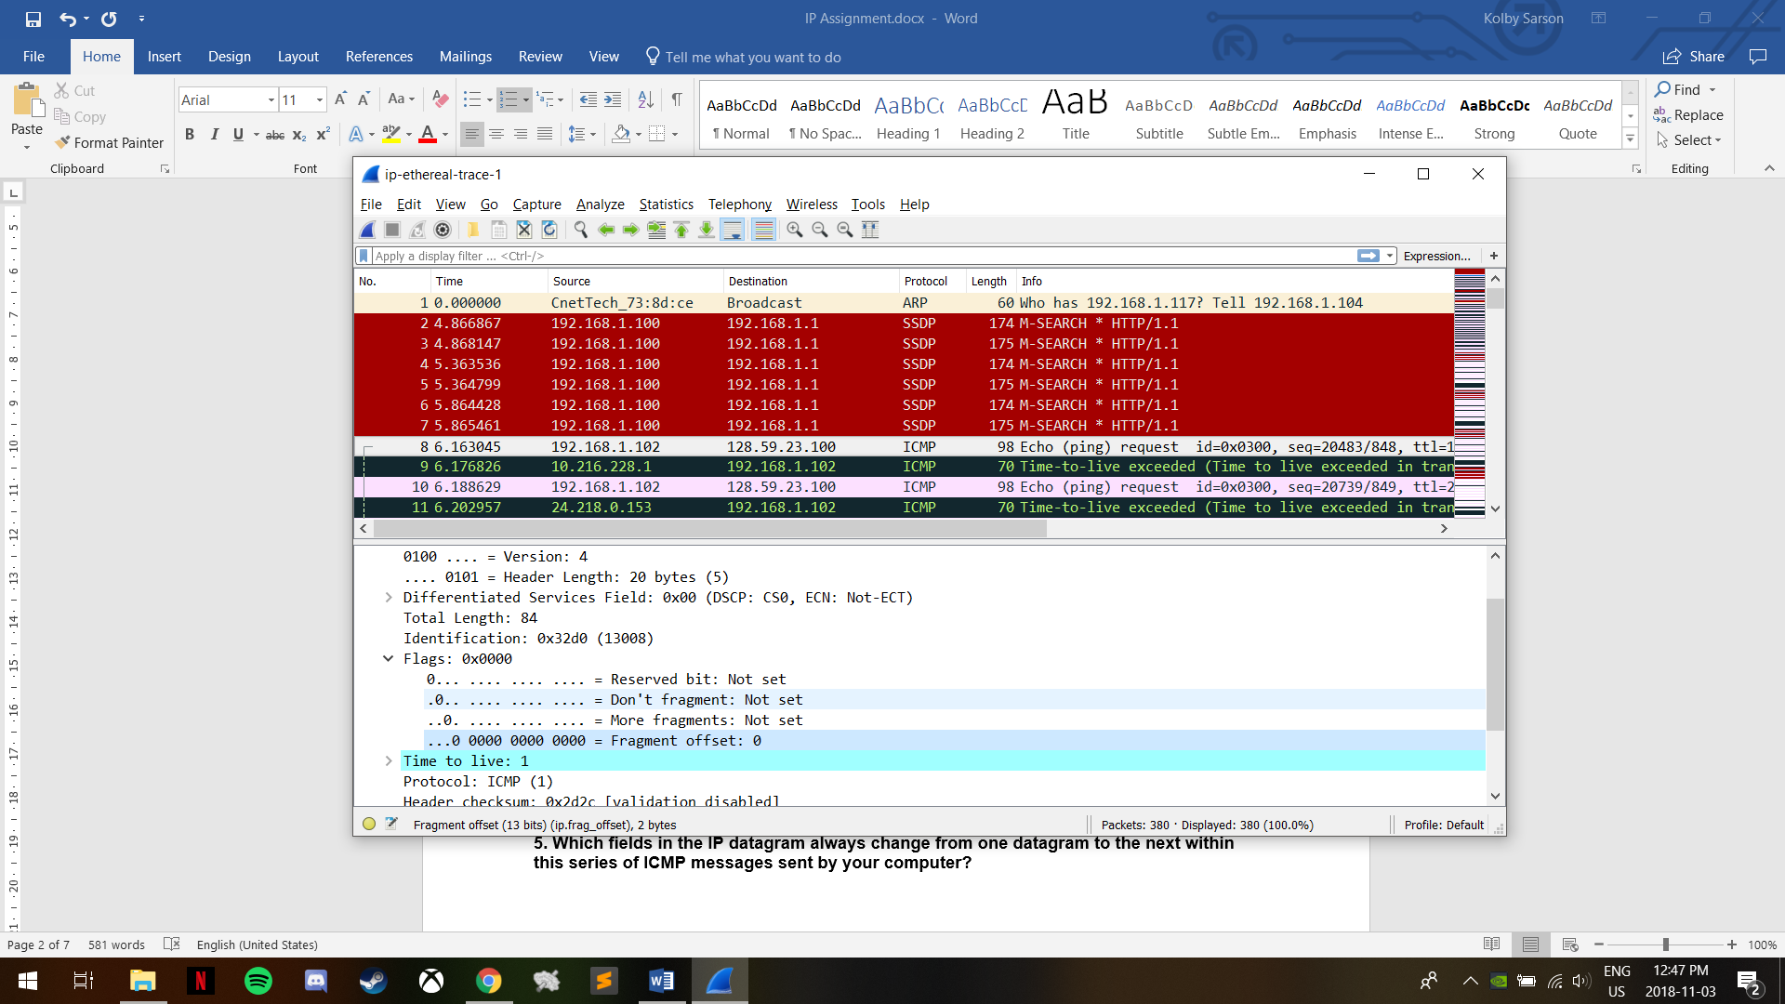

1. Header checksum, Time to Live and Identification change between datagrams.
2. The fields that stay constant and must stay constant (indicated by red) are Version, Header Length, DSF, Protocol, and the Source and Destination IPs. The fields that must change (indicated by black) are the same as the fields from question 5.
3. The patterns I noticed are that the TTL and the Identification increment by 1 each echo request.

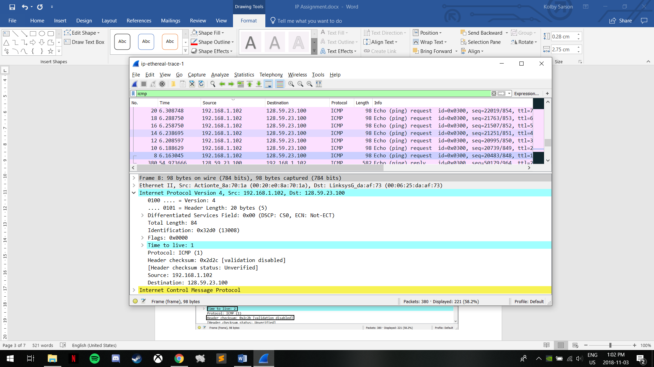

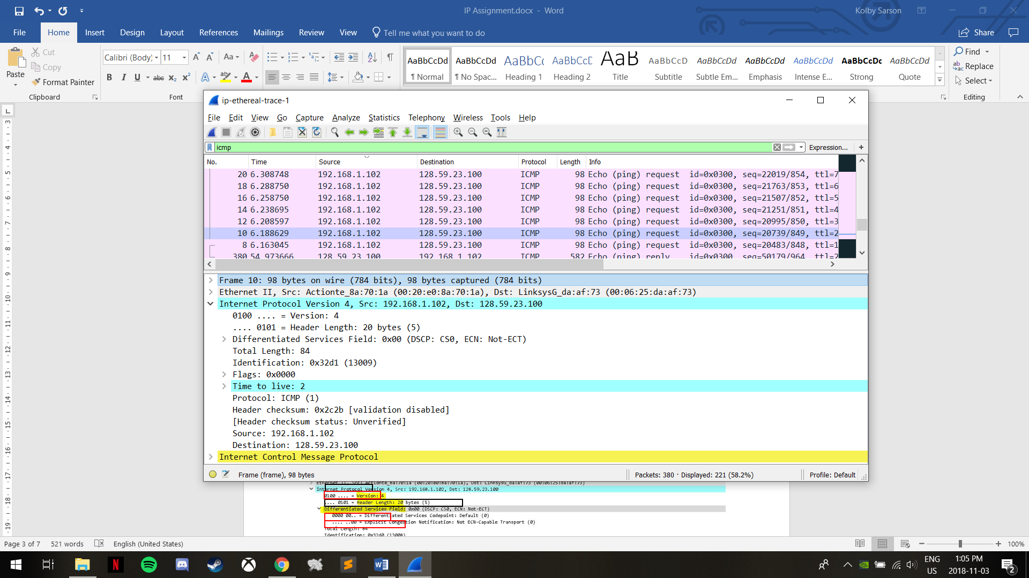

1. The TTL is 255 and the Identification is 40316.

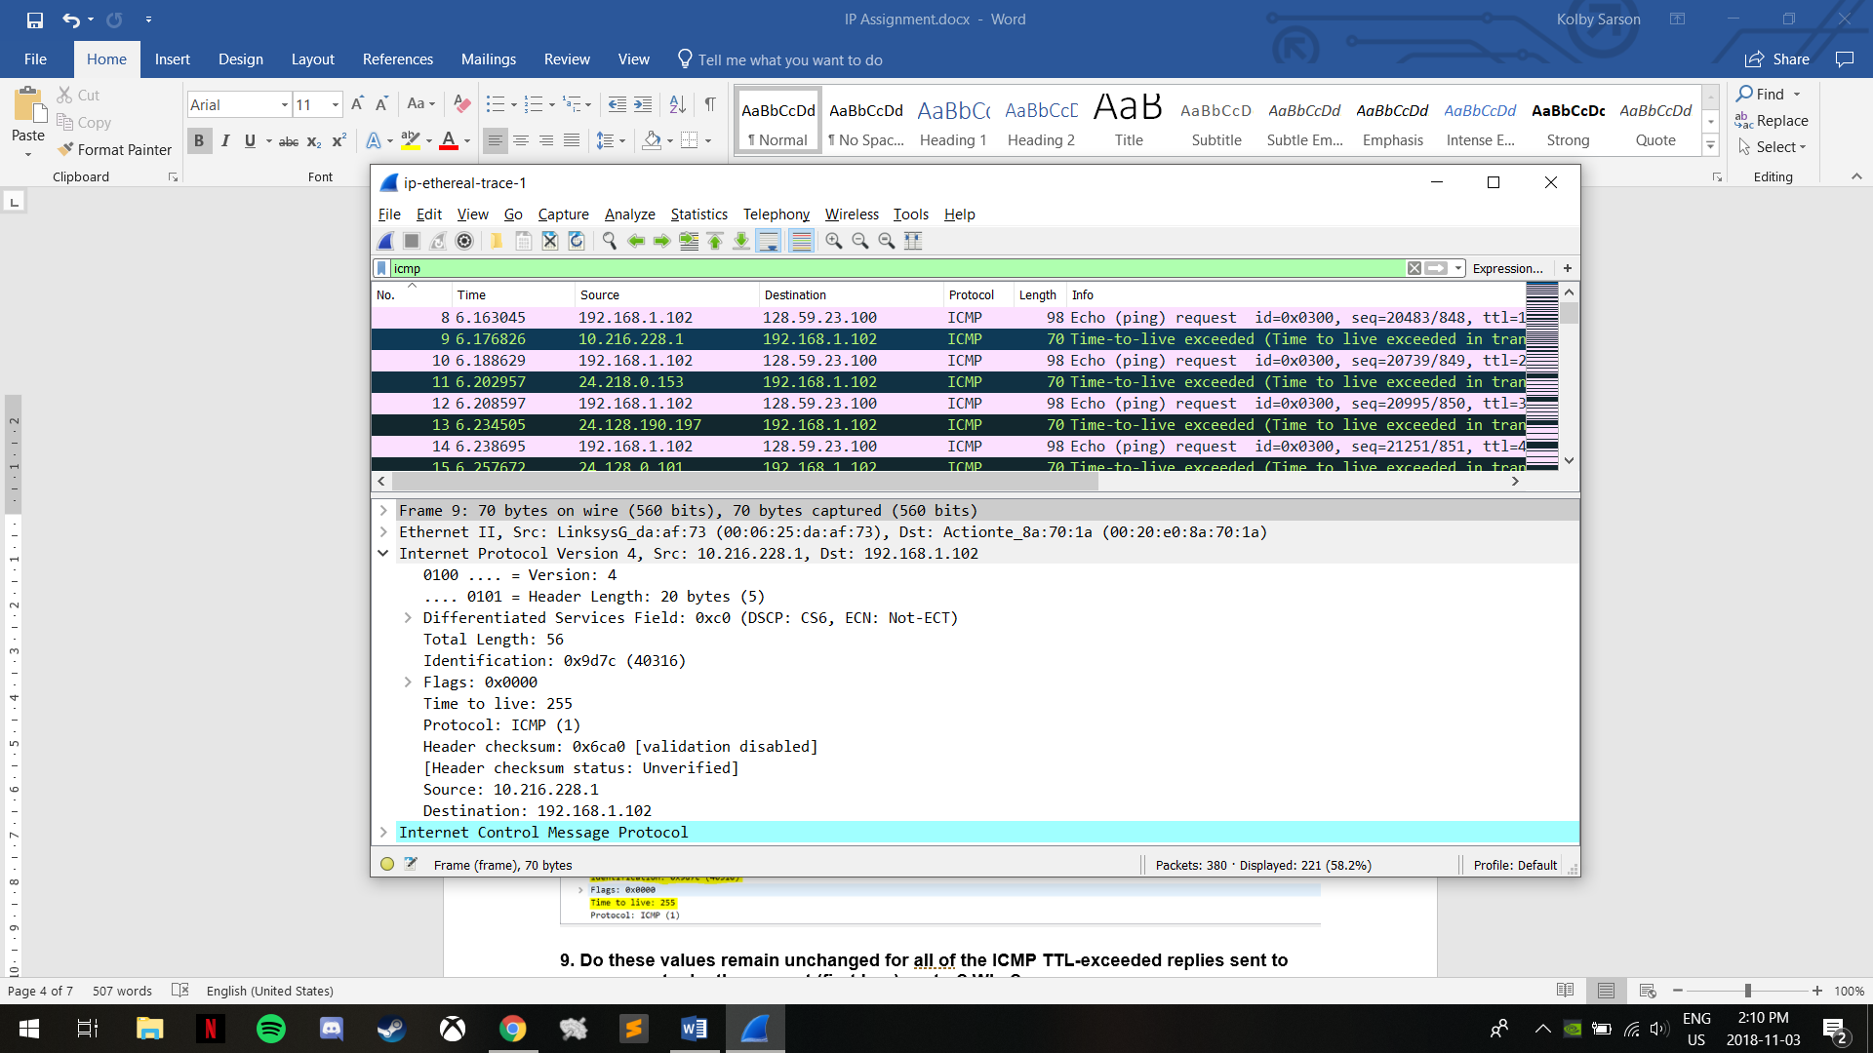

1. The TTL value changes for some, not all, of the TTL-exceeded replies, while the Identification changes for each TTL-exceeded reply.
2. Yes, the message is fragmented.

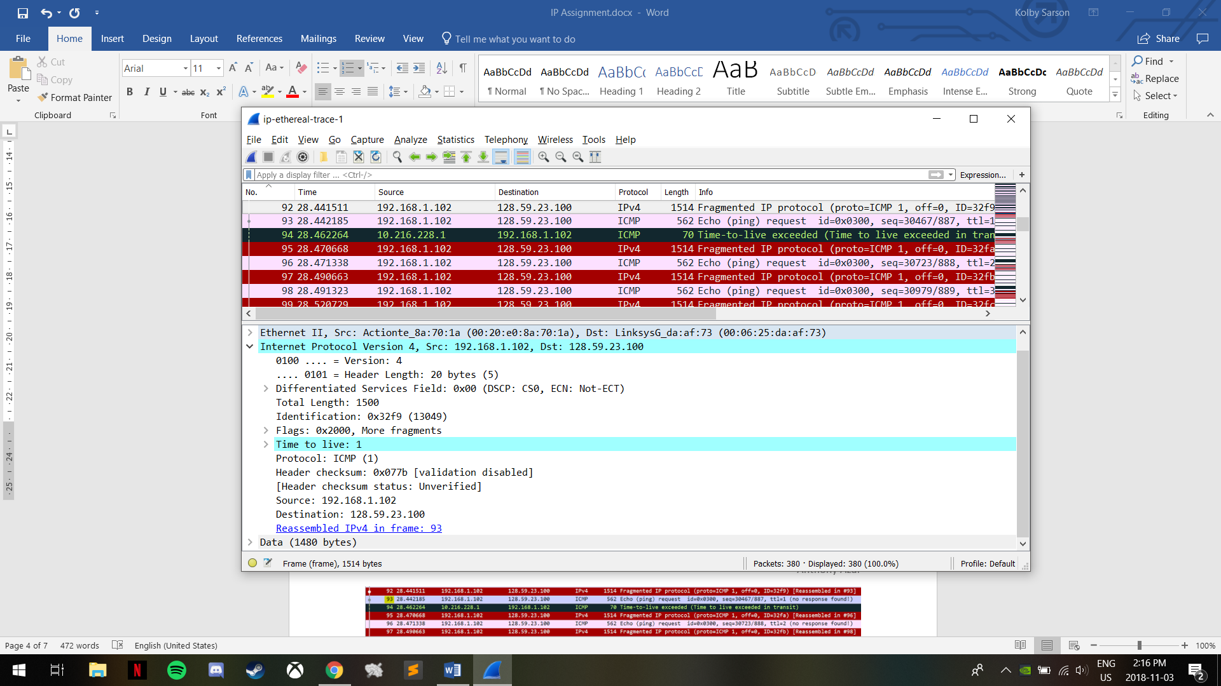

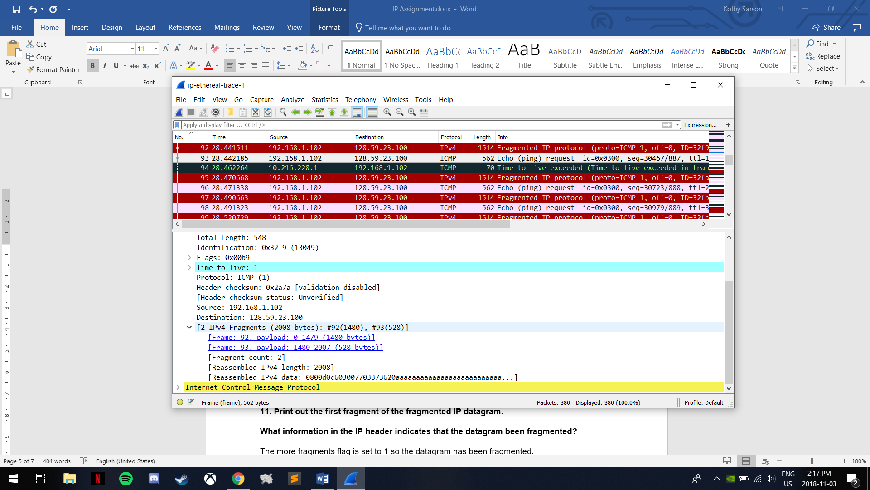

1. The More fragments flag being set to 1 indicates a fragmented datagram. A Fragment offset of 0 indicates that this is the first fragment. The Total Length of the IP datagram is 1500.

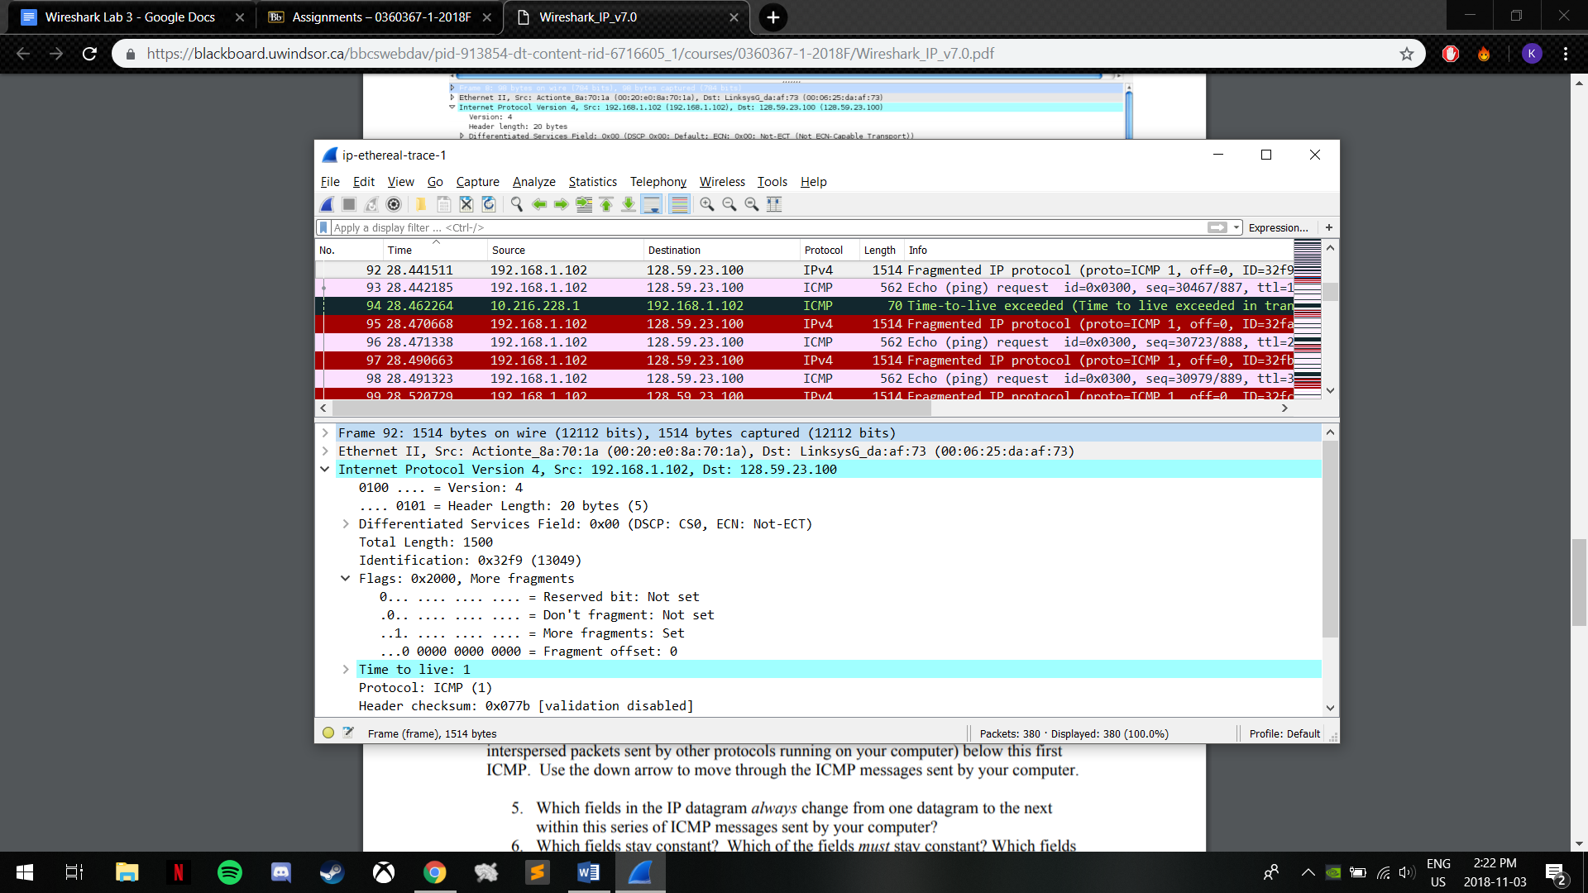

1. The Fragment offset is not 0 so this is not the first fragment. The More fragments flag being not set (0) indicates that there are no more fragments.

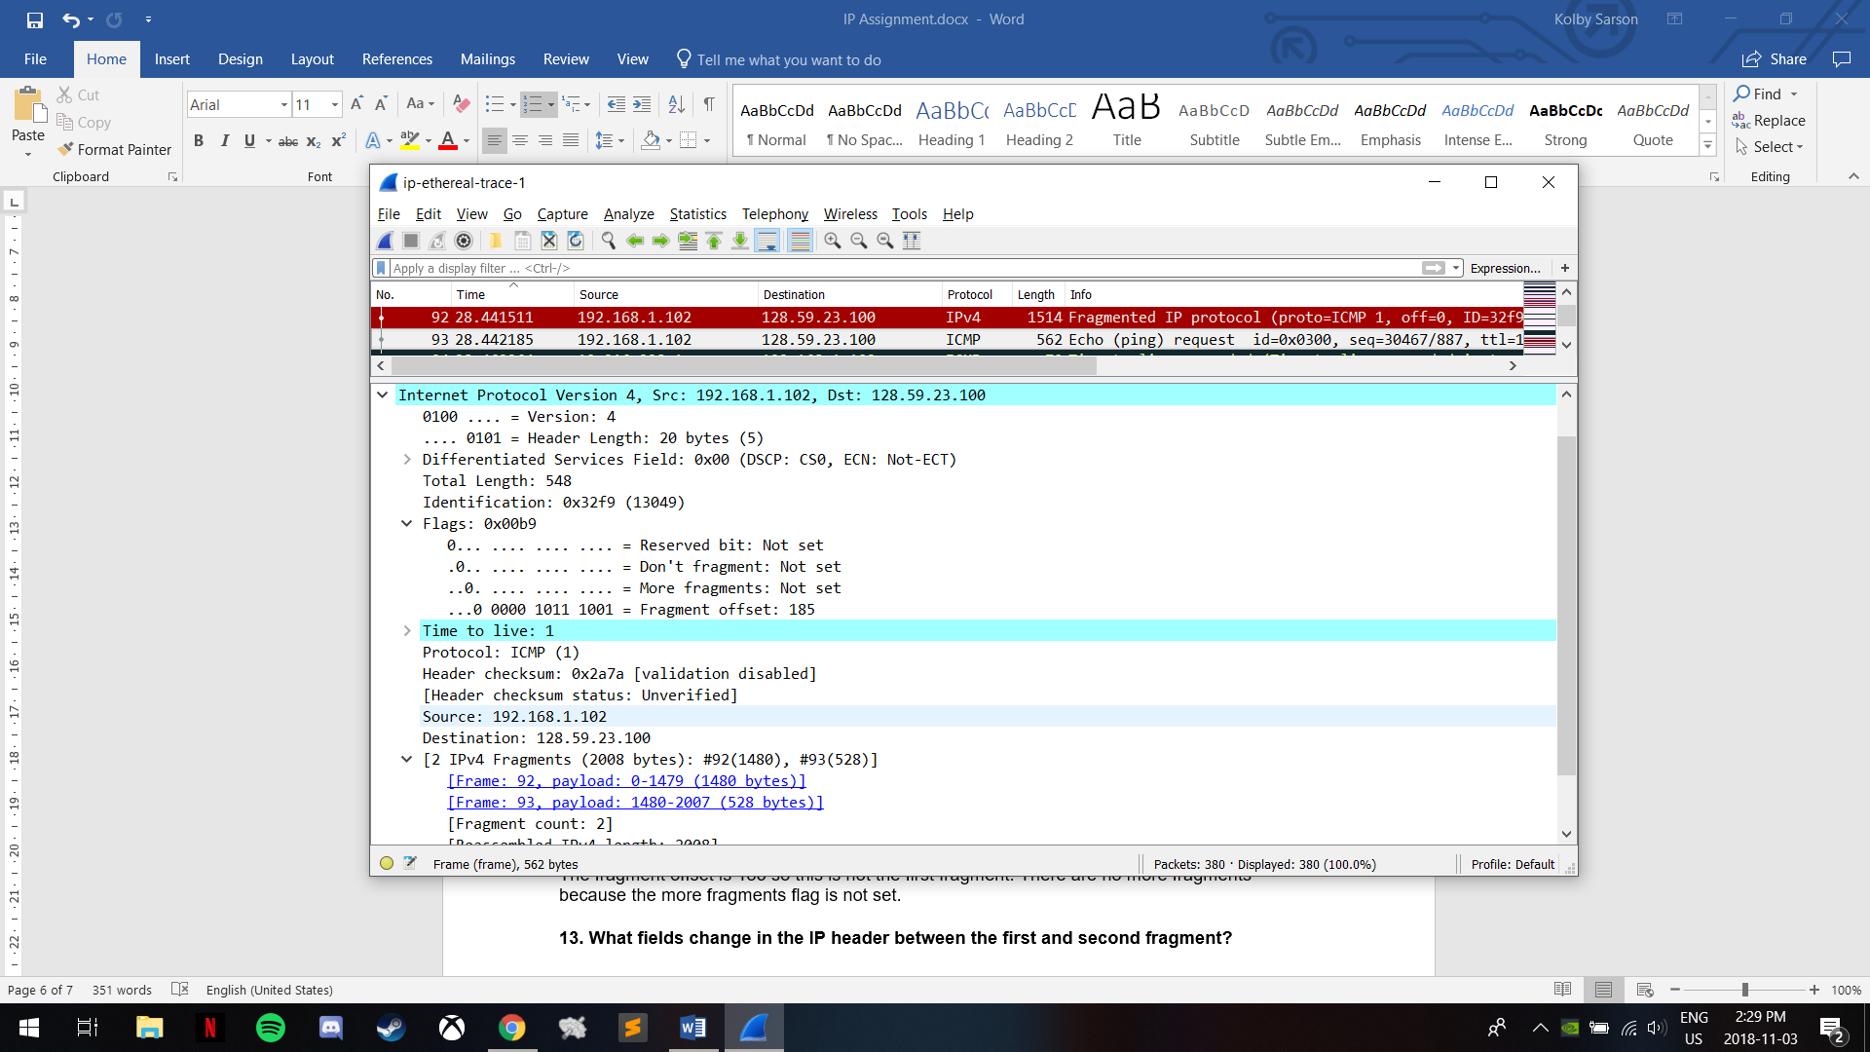

1. The fields that change between the first and second fragments include Flags like Fragment offset and More fragments, the Header checksum, and the Total Length.
2. There are 3 fragments from the original datagram.

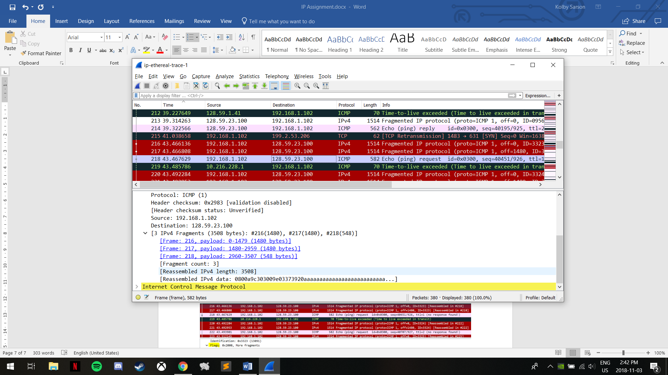

1. The fields that have changed are Fragment offset, Flags, Total Length and Header checksum.

